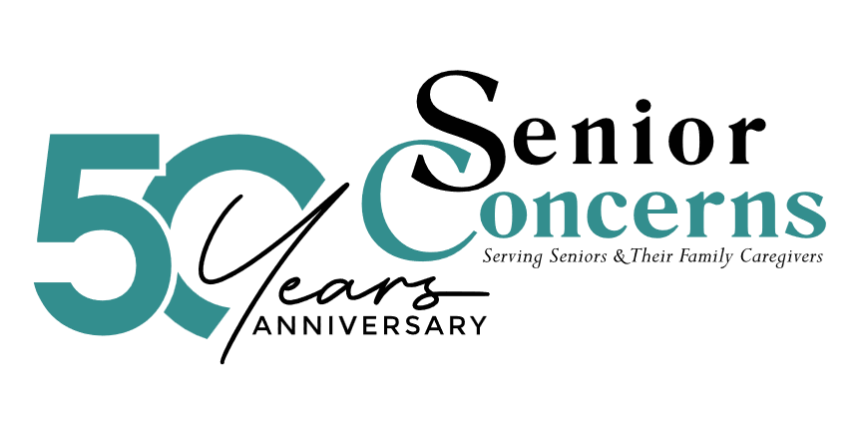

JOB POSTING

Development & Events Coordinator
Senior Concerns | Thousand Oaks, CA | Full-Time, On-Site

About Us
At Senior Concerns, we believe something simple but powerful:
No senior should be left hungry, isolated, or without support.
Each year, we serve over 13,000 older adults and family caregivers—providing meals, care, guidance, and connection that help people live with dignity.

About the Role
We are looking for a highly organized, detail-oriented Development & Events Coordinator to support our fundraising efforts and signature events.
This is an ideal role for someone with 2–4 years of experience who enjoys working behind the scenes while also being part of meaningful, mission-driven work.
You will play a key role in ensuring:
- donors feel appreciated
- data is accurate
- events run smoothly
You’ll also gain exposure to donor relations and fundraising strategy over time.

What You’ll Do
Donor & Data Support
- Maintain and update donor records in our CRM
- Accurately enter and track all gifts
- Generate lists for campaigns and events
Donor Experience
- Prepare timely and personalized thank-you letters
- Help track donor engagement and recognition
- Support meaningful donor interactions and follow-up
Campaign Support
- Assist with annual and seasonal fundraising campaigns
- Support email outreach (Constant Contact)
- Help coordinate materials and timelines
Events & Auctions
- Support planning and execution of events (Ultimate Dining, Love Run, Boat Bash, Golf Tournament)
- Track sponsorships and auction items
- Assist with event logistics and on-site support
General Support
- Assist with light research and special projects
- Support team coordination and occasional front desk coverage
Professional Standards & Ethics
- Maintain strict confidentiality of all donor, financial and organizational information.
- Exercise discretion and sound judgement when handling sensitive data and communications

What You Bring
- 2–4 years of experience in administrative, events, or nonprofit work
- Strong attention to detail (this is critical in this role)
- Comfort working with data, spreadsheets, and systems (CRM experience a plus)
- Excellent organization, time management and follow-through
- Warm, professional communication style
- Ability to manage multiple priorities with accuracy and consistency
- A positive, team-oriented mindset

What Sets You Apart
- You notice when something is off—and fix it
- You follow through without being reminded
- You care about doing things well, not just getting them done
- You understand that details matter – especially when it comes to donor trust
- You take pride in supporting work that helps others

Compensation & Benefits
Non-exempt position – up to $30.00 per hour, depending on experience
- Holidays, vacation and sick time after 90 days
- Health insurance
- Opportunity to participate in 403(b) retirement with employer matching

Why Join Us
- Meaningful, mission-driven work
- Supportive and collaborative team
- Opportunity to grow in nonprofit fundraising and development
- Be part of work that truly impacts seniors and family caregivers in your community

To Apply
Please submit your resume and a brief cover note sharing why this role interests you to: Julie Harvey, Director of Development at jharvey@seniorconcerns.org

